Single Body Free Swimming FLUENT UDF Validation Report

20/05/2021  
Marvin Wright

Validation for Single body simulation using Ansys Fluent + UDF. The UDF follows the model of Carling et to create an undulating model via center line displacement while maintaining mass conversation.

# Methodology

|  |  |
| --- | --- |
| Calculate entre of gravity: $$x_{cg}=\frac{\sum{Axi}}{\sum{A}}, y_{cg}=\frac{\sum{Ayi}}{\sum{A}}$$  $$A_{i}=\frac{a+b}{2}h, xi=x+\frac{\left(a+2b\right)}{3\left(a+b\right)}h,yi=ys\left(xi\right)$$ Calculate mass moment of inertia: $$I=m r^{2}=A ρ r^{2}=\sum{A_{i}}ρ r_{i}^{2}$$  $$r_{i}=\sqrt{{\left(x_{i}-x_{cg}\right)}^{2}+{\left(y_{i}-y_{cg}\right)}^{2}}$$ Equations of motion / numerical integration scheme: (RKK4 and Euler match to high degree for small $∆t$) $$α=M/I$$  $$ω=ω+α∆t$$  $$φ=φ+ω∆t$$  $$a=F/m$$  $$v=v+a∆t$$  $$x=x+v∆t$$ Surface node update algorithm for defined y(s): $$dx_{s}=\sqrt{{\left(ds\right)}^{2}-{\left(dy\right)}^{2}}$$ $$α=\operatorname{asin}\left(\frac{dys}{ds}\right)$$ |  |

The following publications are taken as a Reference:

1. (Zhang, Pan et al. 2018)
2. (Bhalla, Bale et al. 2013)
3. (Kern and Koumoutsakos 2006)
4. (Carling, Williams et al. 1998)

# Comparable cases summary

|  |  |  |  |  |
| --- | --- | --- | --- | --- |
|  | Carling | Kern | Bath | Zhang |
| Method | Inhouse code | Star CD ( now Star CCM+) | Immersed Boundary | Immersed Boundary |
| Shape function | $$y(x,t_{0})= w_{0}-\left(w_{0}-w_{1}\right)\left(3-\frac{2x}{l}\right)\frac{{ s}^{2}}{l^{2}}$$ $$w_{0}=0.64$$ $$w_{1}=0.16$$ $$l=1$$ |  | $$Wh=0.04L, L=1$$ | |
| Amplitude function | $$A(x)= 0.1L\frac{\frac{x}{l}+b}{1+b}$$ $$b=0.25$$ | $$A\left(x\right)=A_{max}\frac{\left(\frac{x}{l}+0.03125\right)}{1.03125}$$ $A_{max}=0.125$ L | | |
| Shape and amplitude graphs | Significant differences in model shape and amplitude function and frequency / cycle period of compared cases. | | | |

|  |  |  |
| --- | --- | --- |
|  |  |  |
|  | = 83 $$ρ=0.997\frac{kg}{cm3}$$ $$d_{0}^{2}=0.001$$ $$μ=1.002 10^{-6}$$ $$t_{0}=1.2$$ | $$ρ=0.997\frac{kg}{cm3}$$ $$d_{0}^{2}=0.015625$$ $$μ=1.002 10^{-6}$$ $$t_{0}=1$$ $⟹Re_{2}$ = 15 |

# Results

Results are presented for a settings matching (Zhang, Pan et al. 2018) validation case, i.e. same geometry, kinematics and Reynolds number.

$$Re_{1}=\frac{V_{max}L}{ν}= 5609$$

$$V_{max}=2πA_{max}f$$

$$ν=1.4 {10}^{-4}, L=0.1, A_{max}= 0.125, f=1$$

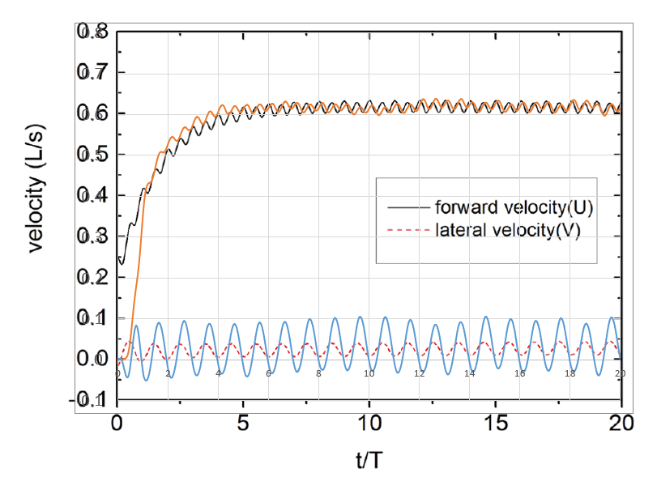 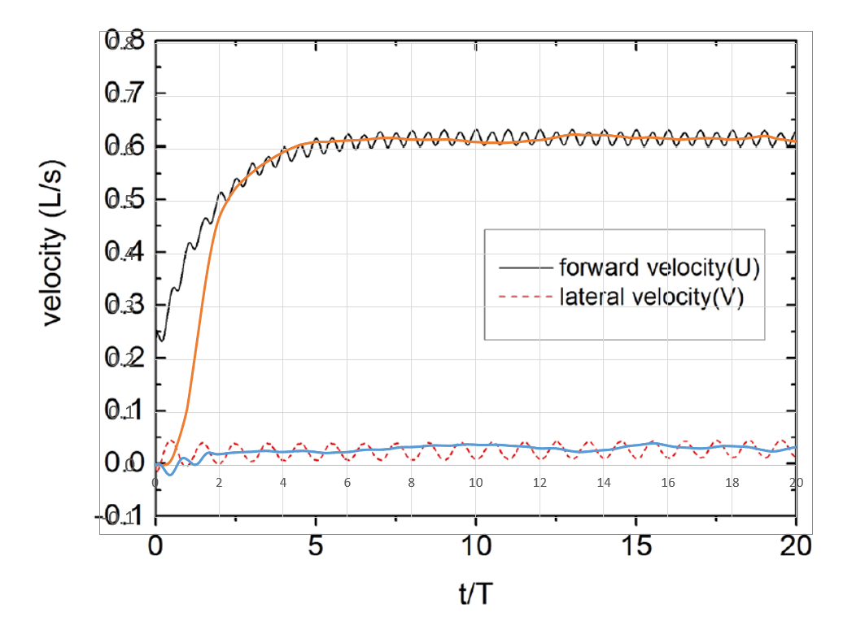

Figure Forward and lateral velocity comparison with (Zhang, Pan et al. 2018) (left) instant (right) cycle average

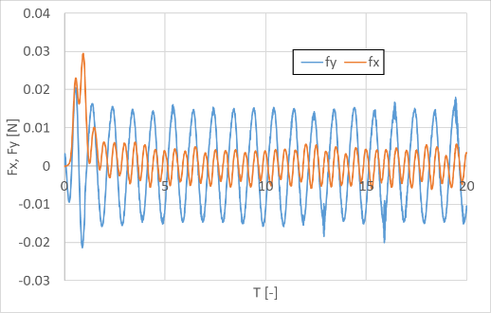 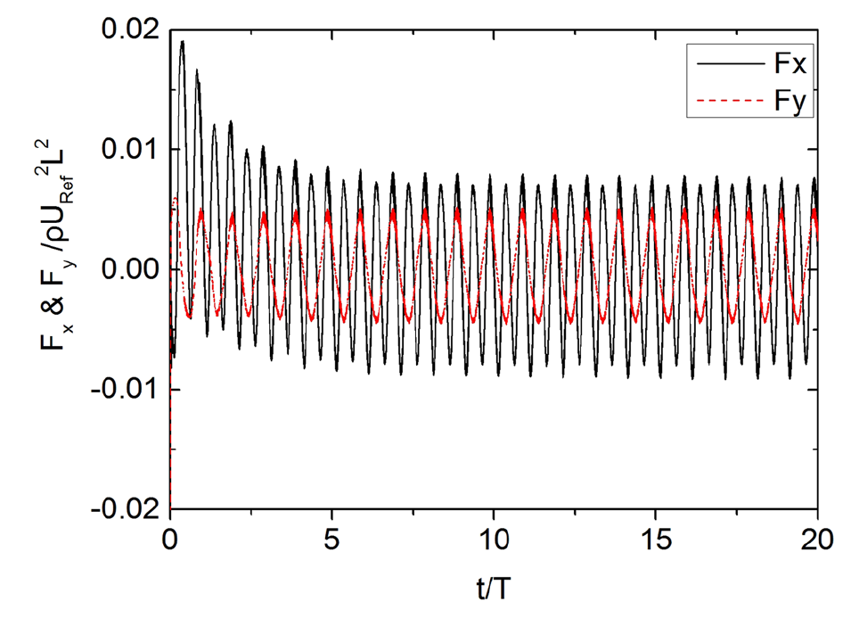

Figure Instantaneous forces (left) Marvin (right) (Zhang, Pan et al. 2018)

Contrary to the Immersed Boundary reference results, the force amplitude of the lateral direction is higher compared to the forward direction. This is reflected in the velocity of Figure 1 showing a higher lateral velocity amplitude compared to the forward amplitude. However, for both the trend is matching to a very high degree. Reference results Y axis is given by $\frac{F}{ρU_{ref}^{2}L^{2}}$. If the same is done for for the simulation results the magnitude changes by ${10}^{4}$ due to the $\frac{1}{U_{ref}^{2}L}={10}^{-4}$ for simulated case of L=0.1m

|  |  |
| --- | --- |
| Figure CG displacement | Comparison of the centre of gravity displacement shows an overall good agreement. While up to x/L= -4 results exact match and slightly diverging after. This can be explained by decreasing mesh quality also represented in fuzzy force curves of figure 2 (left). A finer mesh and adjusted dynamic mesh settings can bring potential improvement. |

# References

Bhalla, A. P. S., et al. (2013). "A unified mathematical framework and an adaptive numerical method for fluid–structure interaction with rigid, deforming, and elastic bodies." Journal of Computational Physics **250**: 446-476.

Carling, J., et al. (1998). "Self-propelled anguilliform swimming: simultaneous solution of the two-dimensional Navier-Stokes equations and Newton's laws of motion." Journal of experimental biology **201**(23): 3143-3166

Kern, S. and P. Koumoutsakos (2006). "Simulations of optimized anguilliform swimming." Journal of experimental biology **209**(24): 4841-4857.

Zhang, D., et al. (2018). "Effects of Reynolds number and thickness on an undulatory self-propelled foil." Physics of Fluids **30**(7): 071902.